Chapter 13 Homework Problems

Problem 13.1

An impact-testing device consists of 20 kg box supported by two 5 kg slender rods. The two rods are set up in parallel so that the box remains level as it swings. If the whole system is released in the upright position shown below, what is the velocity of the box after traveling 90o?

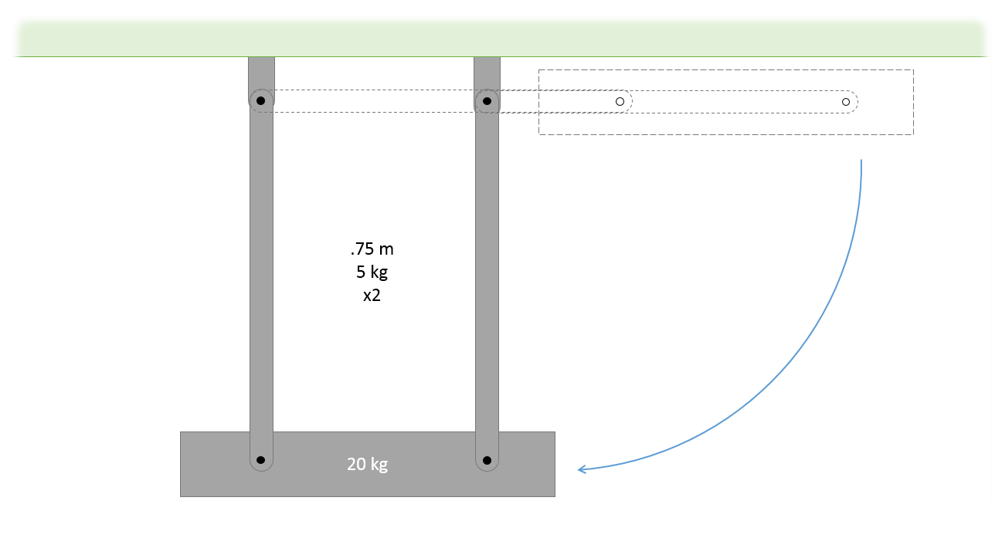

(Solution: v = 3.97 m/s)

Problem 13.2

A 40 lb door with a width of 36 inches has a spring with an unstretched length of 4 in designed to close the door when left open. The spring is anchored as shown below when closed (solid outline is closed, dotted outline is open 90o). If we want the door to have an angular velocity of .2 rad/s upon closing when released from rest at 90o, what should the spring constant of the spring be? (This is the top view of the door below)

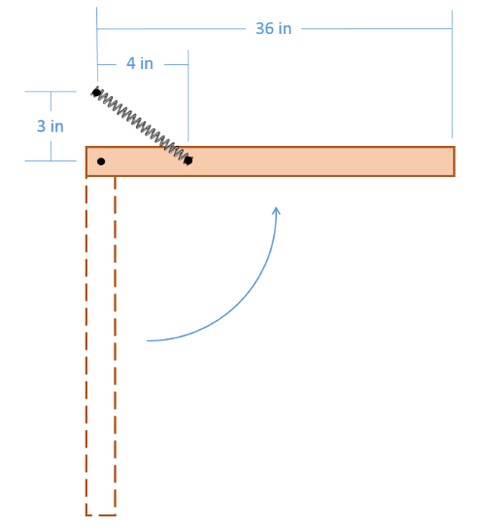

(Solution: k = 2.68 lbs/ft =.224 lbs/in)

Problem 13.3

A bench grinder consists of two wheels each having a diameter of 10 inches and a weight of 6 pounds. If we wish to get the wheels from a stop up to their operating speed of 3500 rpm over the course of 3 seconds, what is the power required for the bench grinder motor in horsepower?



(Solution: P = 1.32 hp)

Problem 13.4

The system of belts and pulleys below has an input at A and an output at D. Pulleys B and C are in the same shaft.

1. Assuming an input at 60 rad/s and no slipping, what is the expected angular velocity at D?
2. Assuming the system is 95% efficient and that the input torque is 30 Nm, what is the expected output torque at D?

(Solution: )